DIGITAL ASSIGNMENT - 1

TEAM MEMBERS:
- 21BCE1950 - OMPRAKASH
- 21BCE5828 - MOHAMED RIYAAS R
MACHINE LEARNING ALGORITHMS APPLIED:
- Logistic Regression
- K Nearest Classifer
TITLE OF THE PROJECT:
- Cardiovascular Risk Assessment
- Heart Health Prognosis
DATASETS TAKEN:
https://thecleverprogrammer.com/wp-content/uploads/2020/05/heart.csv
PERFORMANCE METRICS:
Logistic Regression

Test Result
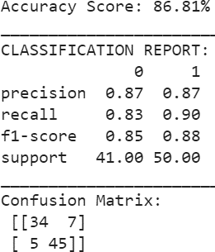

AUC-ROC (“Area Under the Curve” of the “Receiver Operating Characteristic” curve.)
0.9165853658536586

PERFORMANCE METRICS:
Logistic Regression
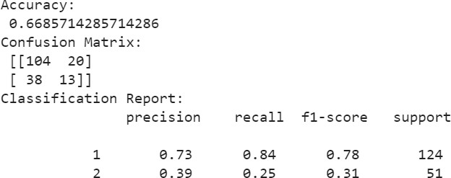

CONTRIBUTION TABLE:

Team Member | Project Taken | Algorithm Used | Contribution
21BCE1950  Omprakash | Heart Health Prognosis | K Nearest Classifier | Executed K Nearest algorithm, calculated cross validation score and visualization and exploration  of data.
21BCE5828  Mohamed Riyaas | Cardiovascular Risk Assessment | Logistic Regression | Executed Logistic Regression algorithm, calculated cross validation score and added AUC- ROC Performance  Metrics.

LINK FOR THE GOOGLE COLAB FILE:
https://colab.research.google.com/drive/1ai_VFvVp9VGfrWT_aGINMnvGIttRdLYo?usp=sh aring
LINK FOR THE IEEE CONFERENCE TO SUBMIT :
https://icoiss.com/committee.html

DEADLINE FOR SUBMISSION:
26th January 2024

